

**COMPUTER ENGINEERING**

**DLCA ODD SEM 2021-22/EXPERIMENT 8 NAME:- GAURAV AMARNANI (D7A, 67)**

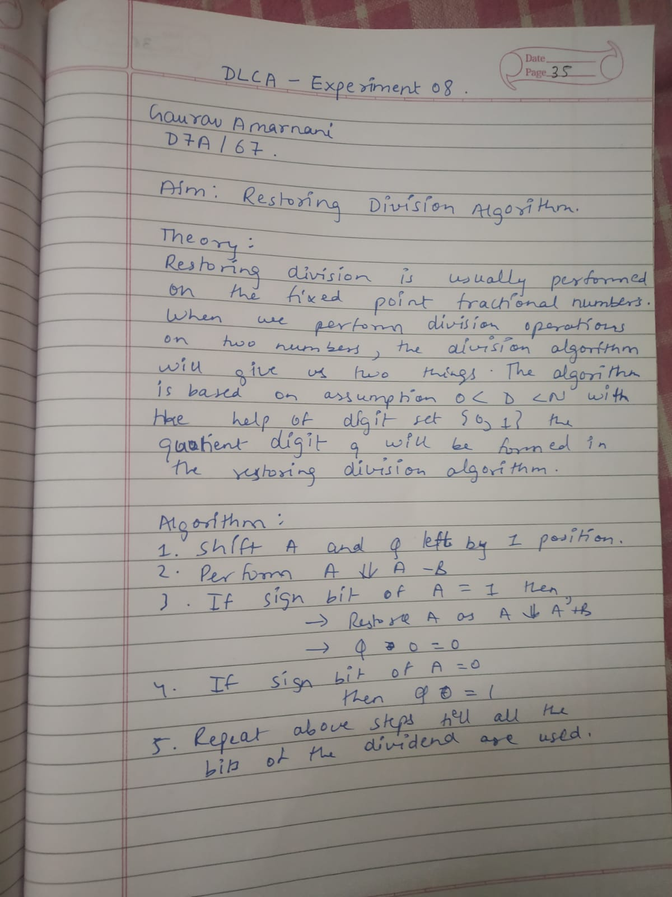

**AIM:** To write a C program for implementation of Restoring Division.

**SOFTWARE:** Turbo C IDE.

**FLOWCHART**

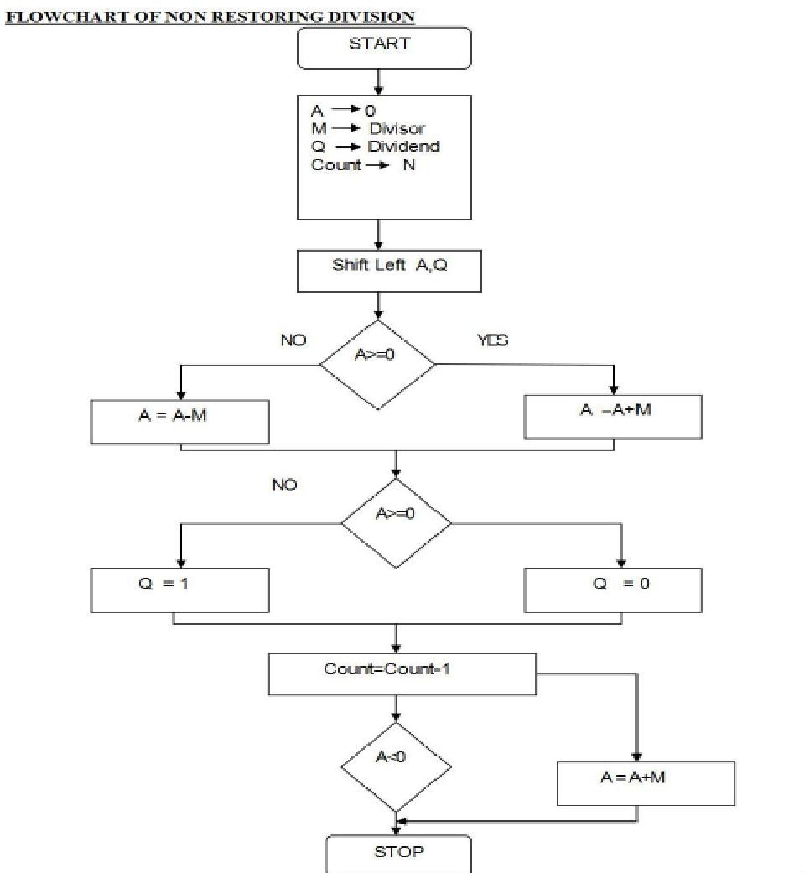

**PROGRAM:**

#include<stdio.h>

#include<math.h>

#include<conio.h>

int getsize(int x) {

int c; if(x<=1)

c = 2;

else if(x < 4) c = 2;

else if(x< 8)

c = 3;

else if(x< 16)

c = 4;

else if(x< 32)

c = 5;

else if(x< 64)

c = 6;

else if(x< 128)

c = 7;

else if(x< 256)

c = 8;

else if(x< 512)

c = 9;

return c;

}

int max(int x,int y) {

if(x< y) return(y);

else return(x);

}

void main() {

int B,Q,Z,M,c,c1,e,f,g,h,i,j,x,y,ch,in,S,G,P;

int a[24],b[12],b1[12],q[12],carry=0,count=0,option;

long num;

clrscr();

do {

printf("| |\n");

printf("|\t\tPROGRAM FOR RESTORING DIVISION\t\t|\n");

printf("| |");

printf("\n\nENTER DIVIDEND\t: ");

scanf("%d",&Q);

y = getsize(Q);

printf("ENTER DIVISOR\t: ");

scanf("%d",&M);

x = getsize(M);

Z = max(x,y);

printf("\n\tTOTAL BITS CONSIDERED FOR RESULT => %d",2*Z+1);

printf("\n\tINITiALLY A IS RESET TO ZERO:");

for(i=0;i<=Z;i++)

printf("%d ",a[i]=0);

for(i=Z;i>=0;i--) {

b1[i] = b[i] = M%2; M = M/2;

b1[i] = 1-b1[i];

}

carry = 1;

for(i=Z;i>=0;i--) {

c1 = b1[i]^carry;

carry = b1[i]&&carry;

b1[i]=c1;

}

for(i=2*Z;i>Z;i--) {

a[i] = Q%2; Q = Q/2;

}

printf("\n\n\tDivisor\t\t(M)\t: ");

for(i=0;i<=Z;i++)

printf("%d ",b[i]);

printf("\n\t2'C Divisor\t(M)\t: ");

for(i=0;i<=Z;i++)

printf("%d ",b1[i]);

printf("\n\tDividend\t(Q)\t: ");

for(i=Z+1;i<=2*Z;i++)

printf("%d ",a[i]);

printf("\n\n\tBITS CONSIDERED:[ A ][ M ]");

printf("\n\t\t\t");

for(i=0;i<=Z;i++)

printf("%d ",a[i]);

printf(" ");

for(i=Z+1;i<=2*Z;i++)

printf("%d ",a[i]);

count = Z;

do{

for(i=0;i< 2*Z;i++)

a[i] = a[i+1];

printf("\n\nLeft Shift\t\t");

for(i=0;i<=Z;i++)

printf("%d ",a[i]);

printf(" ");

for(i=Z+1;i< 2*Z;i++)

printf("%d ",a[i]);

carry=0;

for(i=Z;i>=0;i--) {

S=a[i]^(b1[i]^carry);

G=a[i]&&b1[i];

P=a[i]^b1[i];

carry=G||(P&&carry);

a[i]=S;

}

printf("\nA< -A-M \t\t");

for(i=0;i<=Z;i++) printf("%d ",a[i]);

printf(" ");

for(i=Z+1;i< 2*Z;i++)

printf("%d ",a[i]);

ch=a[0];

printf("\nBIT Q:%d",ch);

switch (ch) {

case 0:

a[2*Z]=1;

printf(" Q0< -1\t\t");

for(i=0;i<=Z;i++)

printf("%d ",a[i]);

printf(" ");

for(i=Z+1;i<=2*Z;i++)

printf("%d ",a[i]);

break;

case 1:

a[2*Z]=0;

printf(" Q0< -0\t\t");

for(i=0;i<=Z;i++)

printf("%d ",a[i]);

printf(" ");

for(i=Z+1;i<2*Z;i++)

printf("%d ",a[i]);

carry=0;

for(i=Z;i>=0;i--) {

S=a[i]^(b[i]^carry);

G=a[i]&&b[i];

P=a[i]^b[i];

carry=G||(P&&carry);

a[i]=S ;

}

printf("\nA< -A+M");

printf("\t\t\t");

for(i=0;i<=Z;i++)

printf("%d ",a[i]);

printf(" ");

for(i=Z+1;i<=2*Z;i++)

printf("%d ",a[i]);

break;

}

count--;

} while(count!=0);

num=0;

printf("\n\n\t\t< < QUOTIENT IN BITS >>:");

for(i=Z+1;i<=2*Z;i++) {

printf("%d ",a[i]);

num=num+pow(2,2*Z-i)*a[i];

}

printf("\n\t\t QUOTIENT IN DECIMAL:%d",num);

num=0;

printf("\n\t\t< < REMAINDER IN BITS>>:");

for(i=0;i<=Z;i++) {

printf("%d ",a[i]);

num=num+pow(2,Z-i)*a[i];

}

printf("\n\n\t\tREMAINDER IN DECIMAL:%d",num);

printf("\n\tDO YOU WANT TO CONTINUE PRESS 0-ESC 1-CONT.:");

scanf("%d",&option);

} while(option!=0);

}

**Output:**

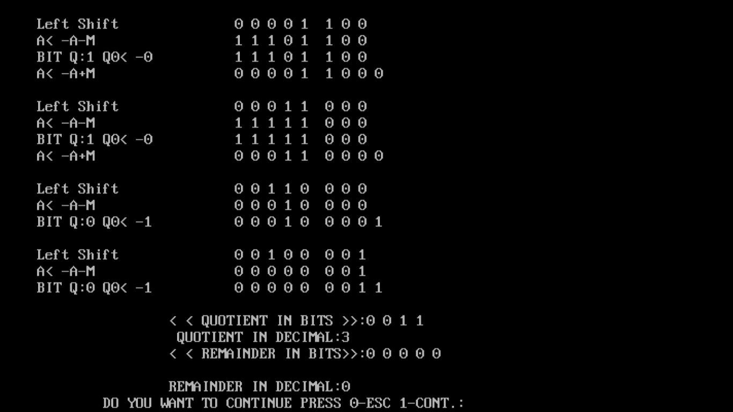

**Conclusion:** We learnt the Restoring division algorithm for an integer. We also learnt a simple approach to solve this problem with the help of a flow chart and applying bit operations.